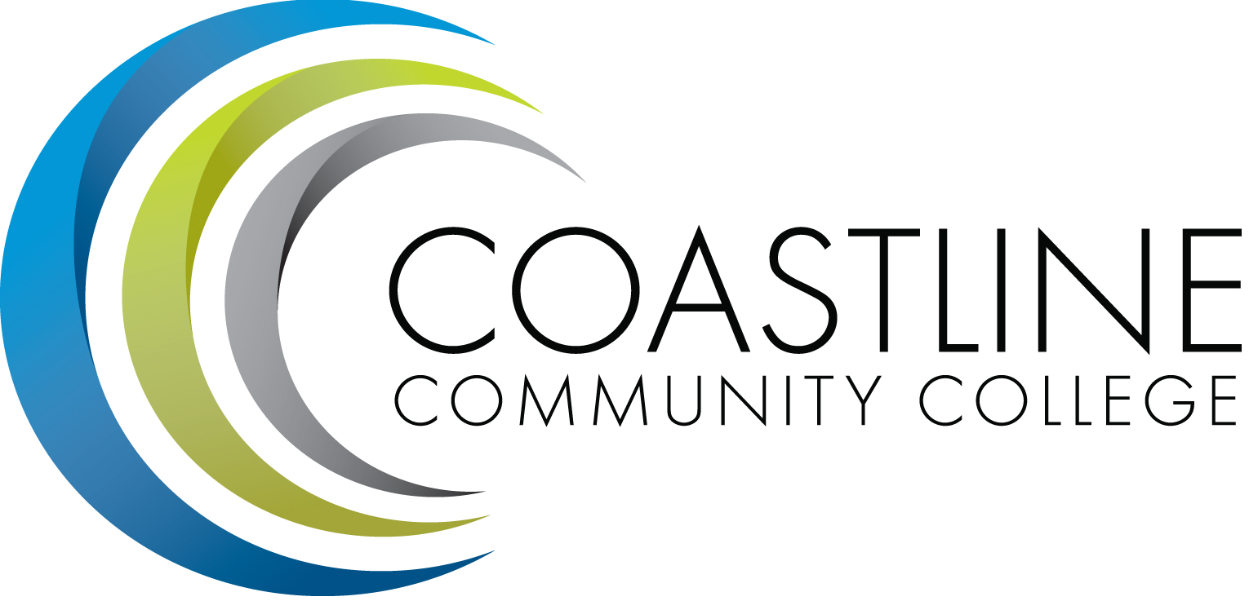
College Council Agenda
November 14, 2017, 9:00-11:00 a.m.
President’s Conference Room, College Center

Committee Mandate: To act on College committee and constituency recommendations, to foster College communication and information sharing, and to review overall College operations.

CALL TO ORDER
  - Welcome
  - Adoption of *Agenda
  - Approval of Minutes: **October 24, 2017

SPECIAL REPORTS
  - Constituent Reports
    - Associated Student Government (Carlos Bahena)
    - Academic Senate (Stephen Barnes)
    - Classified Senate (Kevin Donahue)
    - Management Team (Lori Adrian)

  - College Event Calendar
- Classified Senate 2017 Holiday Boutique, December 1, 2017, 11:00 am to 3:00 pm; College Center
- The Student Art Show, December 12, 2017; Art Gallery
- Military and Veterans Tax Workshop, February 24, 2018, 8:00 a.m. – 3:00 p.m.; NBC
  - President and Executive Team Reports

ACTION ITEMS
  - Follow-Up on Action Items from July 11, 2017 meeting:
3.1.1 Stephen Barnes to discuss proposal of an additional representative to serve on the Facilities Committee in order to represent Art and Science. It has been discovered that the proposal was actually for an additional faculty member vs. a Science representative. Senate will discuss and Stephen will bring back to College Council for further discussion. ONGOING
  - Follow-Up on Action Items from August 22, 2017 meeting:
    - Stephen Barnes will provide a report from the Governance Task Force along with a list of committee members. - Task Force meeting TBD – ONGOING
  - Follow-Up on Action Items from September 26, 2017 meeting:
    - Vince to follow up with Canvas Implementation Team regarding the process which has been created for requesting shells. Vince reported that process is still being reviewed in order to determine needs and identify the population. – ONGOING
    - Carlos to discuss the placement of a student rep on the Accreditation Steering Committee at the next ASG meeting, as requested by Danny Pittaway. Carlos reported that ASG is still in the process of locating a student rep to serve on the Accreditation Steering Committee. However, they have not found anyone available to serve as yet. ONGOING
  - Follow-Up on Action Items from October 10, 2017 meeting:
    - Vince and Stephen to provide follow-up and report on course review process to ensure implementation of RSI for the Financial Aid Federal Program Review. Vince to advise FSC to provide series of workshops on RSI & LDA procedures and guidelines for course review. RSI Task Force has been created and Vince has arranged for workshops to be conducted. Faculty will be contacted directly. – ONGOING
  - Follow-Up on Action Items from October 24, 2017 meeting (new items):
3.5.1 Aeron will provide a report on scorecard breakdown at the next meeting.

STANDING REPORTS
  - Budget Update (Christine Nguyen)
  - PIEAC (Stephen Barnes/Vince Rodriguez)
  - Program/Department Review (Stephen Barnes/Aeron Zentner)
  - Student Success Committee (Stephen Barnes)
  - Facilities, Safety & Sustainability (FSS) Committee (Christine Nguyen)
  - Technology Committee (Christine Nguyen/Joycelyn Groot)
  - Accreditation (Vince Rodriguez)
  - Financial Aid Federal Program Review (Lori Adrian)
  - Scorecard/Achievement Data (Aeron Zentner)
  - Guided Pathways (Lori Adrian/Aeron Zentner)

DISCUSSION ITEMS
  - SSSP/BSI/SE Data and Status (A. Zentner)
  - Planning Wing Scorecards – Revised (A. Zentner)
  - PRT December Visit Update and Documents (A. Zentner/L. Adrian)

ANNOUNCEMENTS

ADJOURNMENT

Next Meeting: November 28, 2017, 9:00 – 11:00 a.m.

*Attachment has been emailed.
**Attachment available at meeting.

